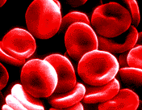
Are red blood cells alive?

Red blood cells have a short life span (120 days)
Red blood cells are formed in red bone marrow. They cannot reproduce.
Red blood cells do not have a nucleus
Red blood cells do not contain any sub-cellular structures
Red blood cells get damaged and wear out
Haemoglobin is an oxygen-binding protein
Red blood cells are bi-concave so they have a large surface area
Red blood cells are very flexible to squeeze through the smallest capillary
Red blood cells are just a membrane bound bag of haemoglobin
In 1mm³ of blood there are 5 million red blood cells
Red blood cells are specialised cells
Red blood cells cannot repair damage or regenerate

