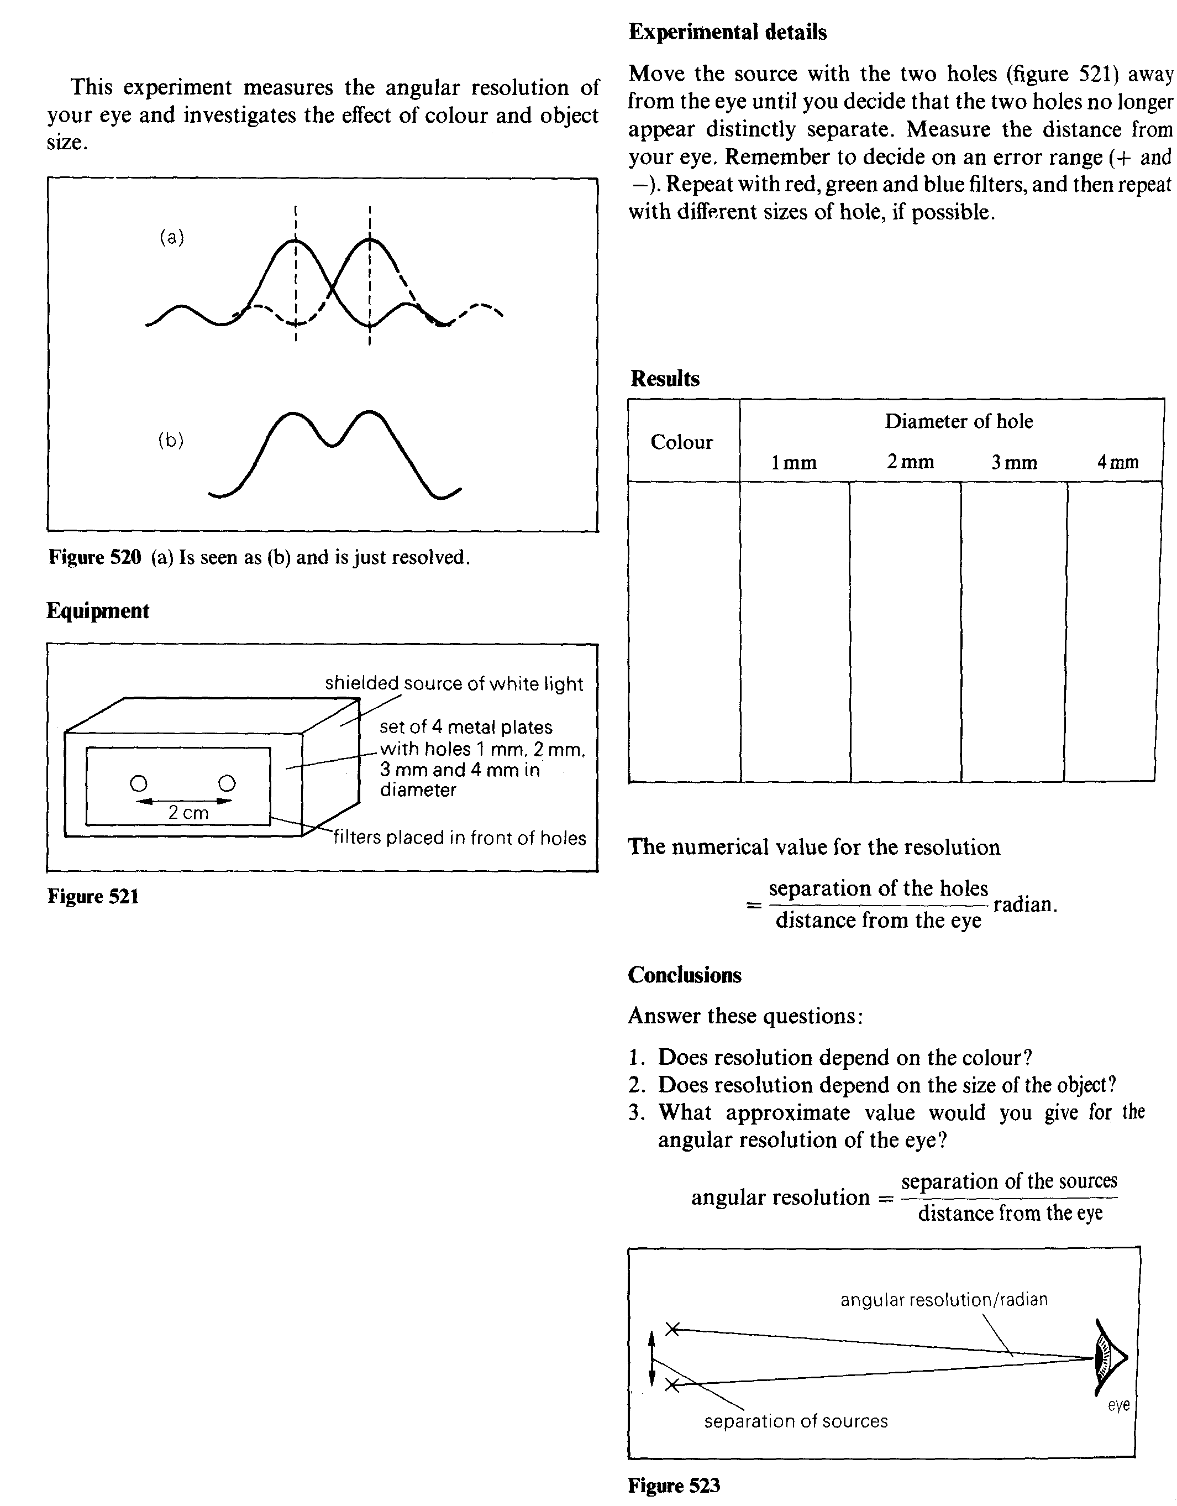
Resolving power of the eye

Theory

When light passes through a hole, a diffraction pattern is produced. E.g. a round source of light often appears blurred at the edges. The hole is the iris of your eye and the size of the objective lens in a telescope all produce diffraction patterns. This affects the “resolving power” of the instrument.

Two sources are said to be resolved when the central maximum of one diffraction pattern is not closer than the first minimum in the pattern of the other. See Fig 520.

